
IP Communications Applications for Business Advantage

Metreos Communications Environment 2.1
Application Suite Administrator Guide
Version 1

Copyright © 2005 Metreos Corporation
All Rights Reserved

Proprietary and Confidential Information
For Release under NDA Only

www.metreos.com | Part Number M-2400-AS-01
 | 6/2005

Information in this document is subject to change without notice.

Copyright © 2005 Metreos Corporation. All rights reserved. Metreos trademarks marked with a ® or © herein are registered or protected trademarks of Metreos in the U.S. and foreign countries. All other trademarks in the document are the property of their respective owners.

Table of Contents

Preface 5
Intended Audience 5
Information This Book Contains 5
Style and Formatting Conventions 5
License/Certification Information 6
1. The Metreos Application Suite 11
Applications in the Suite 11
Metreos ActiveRelay 11
Metreos ClickToTalk 11
Metreos Intercom 11
Metreos RapidRecord 11
Metreos ScheduledConference 11
Metreos VoiceTunnel 12
2. Application Suite Configuration 13
Before You Begin 13
Login 13
Main Configuration Page 14
System Management 15
Change Administrator Password 16
RapidRecord 16
ScheduledConference 16
System 16
Account Management 17
Create User Account 17
Edit User Account 17
Create User Account 18
Entering Account Information 18
Edit User Account 19
Entering Account Information 19
3. Application Suite Reports 21
Account Summary Reports 22
Call Statistics Reports 23
Security and Access Control Reports 23
4. Application Configuration 24
Setting the Trigger Value for Metreos Applications 24
Metreos ActiveRelay Configuration 27
Configuring the Metreos ActiveRelay Cisco IP Phone Service 27
Configuring Metreos ActiveRelay 27
Metreos ClickToTalk Configuration 29
Metreos Intercom Configuration 31
Installing the Metreos Intercom Cisco IP Phone Service 31
Creating Intercom Groups 32
Creating an Intercom Group 33
Configuring Intercom 33
Metreos RapidRecord Configuration 35
Configuring Metreos RapidRecord 35
Metreos ScheduledConference Configuration 37
Metreos VoiceTunnel Configuration 39
Appendix A: Cisco CallManager Setup 42
Common Procedures 42
Global Metreos User Setup 42
Partitions 42
Calling Search Spaces: 42
Calling Search Space Setup: 43
Adding Cisco IP Phone Devices: 43
Cisco IP Phone Services Setup: 44
Creating CallManager Clusters 44
H.323 configuration 44
H.323 Gateway Setup: 45
H.323 Device Setup: 45
Route Patterns for Recording 46
Other Route Patterns 47
JTAPI configuration 47
CTI Route Point Setup 47
Associate the CTI Route Points with the metreos User: 48
Adding lines to the CTI Route Points 48

Preface
This book explains how to deploy and configure the Metreos Application Suite to the Metreos Communications Environment (MCE). This book also describes each application in the suite and how each application is used.

Intended Audience
This book is intended for administrators who are planning to manage the MCE using the Metreos Management Console and the Metreos Application Suite using the Metreos Application Suite Administrative Console.

Information This Book Contains
The MCE Developer Guide is organized into the following Chapters:

- Chapter 1 The Metreos Application Suite – A brief overview the MCE Application Suite
- Chapter 2 Application Suite Configuration – Procedures for configuring the Metreos Application Suite such as system management parameters.
- Chapter 3 Application Suite Reports – Procedures for configuring and using application suite reports
- Chapter 4 Application Configuration – Procedures for configuring each Metreos application
- Appendix A: Cisco CallManager Setup – Procedures for setting up Cisco CallManager for the Metreos Application Suite

Style and Formatting Conventions
The following typographical components are used for defining special terms and command syntax:

Convention | Description
Bold typeface | Represents literal information such as  - Information and controls displayed on screen, including menu options, windows dialogs and field names  - Commands, file names, and directories  - In-line programming elements, such as class names and XML elements when referenced in the main text
Italic typeface | Italics typeface is used to denote  - A new concept  - A variable element such as filename.mca. In this example, filename represents the filename and .mca is the extension.  - A reference to a chapter or section heading
Sans serif typeface | Denotes code or code fragments
… (ellipsis) | Denotes omitted material
UPPERCASE | Denotes keys and keystroke combinations such as CTRL+ALT+DEL.

License/Certification Information

Metreos Corporation

End User License

Important – Use of this Software is subject to license restrictions.
Carefully read this license agreement before using the software.

This End User License Agreement (the “Agreement”) is a legal agreement between you, either individually or as an authorized representative of the company or organization acquiring the license, and Metreos Corporation (“Metreos”). USE OF SOFTWARE INDICATES YOUR COMPLETE AND UNCONDITIONAL ACCEPTANCE OF THE TERMS AND CONDITIONS SET FORTH IN THIS AGREEMENT. If you do not agree to these terms and conditions, promptly return or, if electronically received, certify destruction of the Software and all accompanying items within five days after receipt of Software and you will receive a full refund of the applicable license fees paid.

1. License Grant

a. The software programs you are installing, downloading, or have acquired with this Agreement, including any related equipment or hardware, documentation, updates, upgrades, modifications, revisions, copies and design data (“Software”) are copyrighted, trade secret and confidential information of Metreos and its licensors who maintain exclusive title to all Software and retain all rights not expressly granted by this Agreement. Metreos grants to you, subject to payment of appropriate license fees, a non-exclusive, non-transferable, internal-use only, term license to use the Software owned or distributed by Metreos in machine readable, object-code form on the computer hardware or at the site(s) for which an applicable license fee has been paid, as authorized by Metreos.

b. To the extent that you design applications that operate on the Metreos Communications Environment (the “MCE”), Metreos grants you a non-exclusive, non-transferable, internal-use only, term license to use the Software, including the MCE, for the purposes of operating such programs, subject to payment of appropriate license fees.

c. The license granted herein is contingent on your (or your organization’s) continued acceptance and subscription to the maintenance and support terms provided by Metreos. Termination by you or your organization of ongoing maintenance and support requirements terminates the license granted herein.

2. Restrictions and Intellectual Property Ownership

a. You may not (i) remove or modify any notice of Metreos’ proprietary rights, (ii) re-license, rent, lease, timeshare, or act as a service bureau or provide subscription services for the Software, (iii) use the Software to provide third-party training, except for training agents and contractors authorized under this Agreement; (iv) assign this Agreement or give the Software or an interest in the Software to another individual or entity; (v) cause or permit reverse engineering or decompilation of the Software; (vi) disclose results of any Software benchwork tests without Metreos’ prior written consent; or (vii) modify the Software or any portions thereof without Metreos’ prior written consent.

b. The Software, which is copyrighted, and any modifications, upgrades, or updates thereto, is the sole and exclusive property of Metreos and is a valuable asset and trade secret of Metreos. Metreos retains all ownership and intellectual property rights to the Software and to any modifications, upgrades, or updates thereto. Except for the rights granted in herein above, you shall have no right, title, or interest of any kind in or to the Software.

c. Metreos may audit your use of the Software. If Metreos gives you or your organization reasonable advance written notice, you agree to cooperate with the audit, and to provide reasonable assistance and access to information. You agree to immediately remit any underpaid license and technical support fees determined as the result of such audit.

3. Term and Termination.

a. This Agreement remains effective until expiration or termination. This Agreement will immediately terminate upon notice if you exceed the scope of the license granted or otherwise fail to comply with the provisions in sections 1 and 2 above. For any other material breach of the Agreement, Metreos may terminate this Agreement if you are in breach and fail to cure the breach within thirty (30) days of written notification. If Software is provided for a limited term use, this Agreement will automatically expire at the end of the authorized term.

b. Upon termination of this Agreement for any reason, you shall within ten (10) business days return to Metreos all Software. Additionally, you agree to delete from any permanent machine storage (i.e., hard disk) previously loaded copies of the Software in all forms. Upon request of Metreos, you shall certify in writing that all copies of the Software and associated documentation have been destroyed or returned to Metreos. The indemnity and limitation of liability obligations hereunder, as well as your obligations with respect to confidential treatment of the Software and Metreos’ trade secrets, other intellectual property, and proprietary information, shall survive the termination of this Agreement.

4. Limited Warranty.

a. Metreos warrants that the Software will substantially operate as described in the applicable Software documentation for ninety (90) days after Metreos delivers it to you. THE WARRANTY HEREIN IS EXCLUSIVE AND IN LIEU OF ALL OTHER WARRANTIES, WHETHER EXPRESS OR IMPLIED, INCLUDING THE IMPLIED WARRANTIES OF MERCHANTABILITY AND FITNESS FOR A PARTICULAR PURPOSE. METREOS MAKES NO WARRANTY THAT ANY SOFTWARE WILL PERFORM ERROR-FREE OR UNINTERRUPTED, OR THAT ALL ERRORS THEREIN CAN OR WILL BE CORRECTED. METREOS FURTHER DISCLAIMS ANY IMPLIED WARRANTIES ARISING FROM COURSE OF PERFORMANCE, COURSE OF DEALING OR USAGE OF TRADE.

b. For any breach of the above warranty, Metreos’ entire liability and your exclusive remedy shall be, at Metreos’ option, either (1) refund of the fees paid upon return of the Software to Metreos, or (2) correction or replacement of the Software that does not meet this limited warranty, provided you have complied with the terms of this Agreement.

5. Indemnity

a. Metreos will defend and indemnify you against a claim that any Software, infringes a patent or copyright, provided that: (i) you notify Metreos in writing within thirty (30) days of the claim; (ii) Metreos has sole control of the defense and all related settlement negotiations; and (iii) you provide Metreos with the assistance, information, and authority reasonably necessary to perform the above; reasonable out-of-pocket expenses incurred by you in providing such assistance will be reimbursed by Metreos.
b. Metreos shall have no liability for any claim of infringement resulting from: (i) your use of a superseded or altered release of the Software if infringement would have been avoided by the use of a subsequent unaltered release of the Software which Metreos provides to you; or (ii) any information, design, specification, instruction, software, data, or material not furnished by Metreos or (iii) any combination of the Software with other hardware, software or processes that, but for the combination, the Software would not be infringing.
c. In the event that some or all of the Software is held or is believed by Metreos to infringe, Metreos shall have the option, at its expense: (i) to modify the Software to be non-infringing; or (ii) to obtain for you a license to continue using the Software. If it is not commercially feasible to perform either of the above options, then Metreos may require from you return of the infringing Software and all rights thereto. Upon return of the infringing Software to Metreos, you may terminate the Agreement with ten (10) days’ written notice and you shall be entitled to a pro-rata refund of the fees paid for the infringing Software. This subsection sets forth Metreos’ entire liability and exclusive remedy for infringement.
d. You will defend and indemnify Metreos and its licensors against any claim incurred by, borne by or asserted against Metreos or its licensors that relates to or results from (i) your use of the Software, (ii) any intentional or willful conduct or negligence by you or (iii) any breach of an applicable representation, covenant or warranty contained herein.
e. Should the party seeking indemnification (“Indemnitee”) reasonably determine that the party from whom indemnity is sought (“Indemnitor”) has failed to assume the defense of any claim referenced herein, Indemnitee shall have the right to assume such defense and have all expense and cost of the defense reimbursed by Indemnitor, including reasonable attorneys fees.

6. Confidentiality

The Software contains proprietary and confidential information of Metreos as well as trade secrets owned by Metreos. You agree to hold the Software in strict confidence and not to disclose the Software in any way except as expressly permitted hereunder. You agree to protect the Software at least to the same extent that you protect your similar confidential information, but in no event less than reasonable care. You further agree that you will not, directly or indirectly, copy the structure, sequence, or organization of the Software, nor will you copy any portion of the Software or related documentation to produce software programs that are substantially similar to the Software.

7. LIMITATION OF LIABILITY

EXCEPT WHERE THIS EXCLUSION OR RESTRICTION OF LIABILITY WOULD BE VOID OR INEFFECTIVE UNDER APPLICABLE LAW, IN NO EVENT WILL METREOS BE LIABLE FOR ANY INDIRECT, INCIDENTAL, SPECIAL, OR CONSEQUENTIAL DAMAGES, OR DAMAGES FOR LOSS OF PROFITS, REVENUE, DATA, OR USE, INCURRED BY YOU OR ANY THIRD PARTY, WHETHER IN AN ACTION IN CONTRACT OR TORT, EVEN IF METREOS OR ANY OTHER PERSON HAS BEEN ADVISED OF THE POSSIBILITY OF SUCH DAMAGES. METREOS’ LIABILITY FOR DAMAGES HEREUNDER SHALL IN NO EVENT EXCEED THE AMOUNT OF FEES PAID BY YOU FOR THE SOFTWARE OR SERVICE GIVING RISE TO THE CLAIM. IN THE CASE WHERE NO AMOUNT WAS PAID, METREOS SHALL HAVE NO LIABILITY FOR ANY DAMAGES WHATSOEVER.

8. Assignment; Jurisdiction.

This Agreement will be binding upon, and will inure to the benefit of, the permitted successors and assigns of each party hereto. You may not assign, delegate, transfer, or otherwise convey this Agreement, or any of its rights hereunder, to any entity without the prior written consent of Metreos, and any attempted assignment or delegation without such consent shall be void. This Agreement, and all matters arising out of or relating to this Agreement, shall be governed by the laws of the State of Texas, United States of America. Any legal action or proceeding relating to this Agreement shall be instituted in any state or federal court in Travis or Dallas County, Texas, United States of America. Metreos and you agree to submit to the jurisdiction of, and agree that venue is proper in, the aforesaid courts in any such legal action or proceeding.

9. Severability; Waiver

In the event any provision of this Agreement is held to be invalid or unenforceable, the remaining provisions of this Agreement will remain in full force. The waiver by either party of any default or breach of this Agreement shall not constitute a waiver of any other or subsequent default or breach. Except for actions for nonpayment or breach of either party’s intellectual property rights, no action, regardless of form, arising out of this Agreement may be brought by either party more than two years after the cause of action has accrued. The headings appearing in this Agreement are inserted for convenience only, and will not be used to define, limit or enlarge the scope of this Agreement or any of the obligations herein.

10. Restricted Rights Notice.

The Software is commercial in nature and developed solely at private expense. The Software is delivered as "Commercial Computer Software" as defined in DFARS 252.227-7014 (June 1995) or as a commercial item as defined in FAR 2.101(a) and as provided with only such rights as are provided in this Agreement, which is Metreos’ standard commercial license for the Software. Technical data is provided with limited rights only as provided in DFAR 252.227-7015 (Nov. 1995) or FAR 52.227-14 (June 1987), whichever is applicable.

11. Payment; Interpretation; Compliance.

You will pay all amounts invoiced, in the currency specified on the invoice, within 30 days from the date of such invoice. This Agreement constitutes the complete agreement between the Parties and supersedes all previous and contemporaneous agreements, proposals, or representations, written or oral, concerning the subject matter of this Agreement. This Agreement may not be modified or amended except in a writing signed by a you and Metreos; no other act, document, usage, or custom shall be deemed to amend or modify this Agreement. It is expressly agreed that the terms and conditions of this Agreement supersede the terms of any purchase order. Each party agrees to comply with all relevant export laws and regulations of the United States and the country or territory in which the Services are provided (“Export Laws”) to assure that neither any deliverable, if any, nor any direct product thereof is (a) exported, directly or indirectly, in violation of Export Laws or (b) intended to be used for any purposes prohibited by the Export Laws, including without limitation nuclear, chemical, or biological weapons proliferation. Each party agrees to comply with all federal, state and local laws and regulations applicable to this Agreement. Each party represents and warrants that it is qualified to do business in the geographies in which it will perform its obligations under this Agreement, and will obtain all necessary licenses and permits, and satisfy any other legal, regulatory and administrative requirements, necessary to its performance hereunder.

The Metreos Application Suite
The Metreos Application Suite™ is a collection of the most in-demand voice over IP applications for the enterprise. Each application in the suite is a complete IP telephony application, ready to deploy and run at your site. Since each application is built using Metreos visual tools and executes within the Metreos runtime environment, each is easily and quickly customizable by your staff or integrator.

Applications in the Suite
The Metreos Application Suite includes the following IP telephony business applications. The presence of any individual application in your deployment is dependent on the license in effect.

Metreos ActiveRelay
Metreos ActiveRelay™ allows your business contacts to call you using a single number, regardless of your physical location. Metreos ActiveRelay bridges your cellular telephone to your office telephone and rings both simultaneously, allowing you to answer either phone.

Once connected, you can easily transfer the call to other devices that are configured with ActiveRelay. To the caller, the call sounds like a normal call, and does not exhibit multiple ring sequences common to older style call forwarding applications.

Metreos ClickToTalk
Metreos ClickToTalk™ is a speed dialing application permitting the calling of any party in a contact list with a single click. Metreos ClickToTalk can be used by anyone in a Cisco CallManager group using a Cisco 7940, 7960, or 7970 IP telephone. A ClickToTalk user might select an entry from his or her Microsoft Outlook contact list, click a button on the Outlook tool bar, and ClickToTalk will dial that contact from that user’s IP phone. Conferencing and recording of calls are also supported.

Metreos Intercom
Metreos Intercom™ permits instant communication over IP phones without the need to dial a number. After lifting the handset, you select users from a menu, and audio connectivity is instantly established. Metreos Intercom can be configured to act as a group paging system for the broadcast of voice messages or pages, similar to a traditional paging system. Using the TalkBack feature, an intercom listener can press the Reply button and conference instantly with each party in the intercom group.

Metreos RapidRecord
Metreos RapidRecord™ automatically records calls placed to and from a configured group of frontline devices, permitting seamless, hands-off call recording. Recorded calls can be played back either from a Web interface, or directly from the IP phone that placed or received the call. Metreos RapidRecord records every call from beginning to end. Users then have the option to save or not save the recording.

Metreos ScheduledConference
Metreos ScheduledConference™ is a Web-scheduled dial-in and dial-out conferencing system. Conferences can be scheduled from an easy-to-use Web interface eliminating the need for costly operator or administrative assistance when setting up conference calls. Features include the adding of conference parties, party mute and unmute, and removal of participants from conference.

Metreos VoiceTunnel
Metreos VoiceTunnel™ allows a remote user to connect to any enterprise IP communications system and place calls as if they were local to the system. With Metreos VoiceTunnel, the enterprise can
- Place all calls locally, avoiding international and long-distance toll charges.
- Authenticate call usage and apply a broad range of policies to the billing and accounting of communications costs.
- Manage, monitor, and report on usage of the communications system.

Application Suite Configuration

As the communications system administrator you can use the Metreos Application Suite Administration Console to perform remote configuration of and reporting for the Metreos Application Suite. The Administration Console includes facilities for the configuration of all applications in the suite, and provides easy access to a comprehensive set of reporting and accounting functions.

Before You Begin
Each application in the Metreos Application Suite runs in the context of the Metreos Application Runtime Environment. You should therefore configure the Metreos Application Runtime Environment.

Login
Navigate to the administration URL (http://yourserver/appsuiteadmin/) using a Web browser to display the login page as shown in Figure 1:

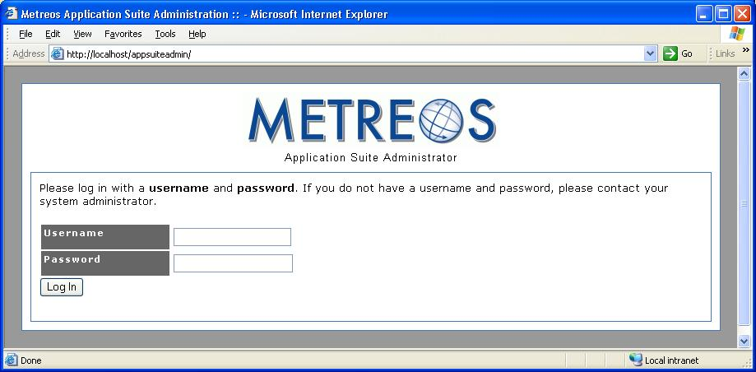
Figure 1: Application Suite Login
The user name is initially set to administrator and the password is initially set to metreos. After you login the first time you will have the opportunity to change the password. You can then access all configuration and reporting options of the Metreos Application Suite.

Main Configuration Page

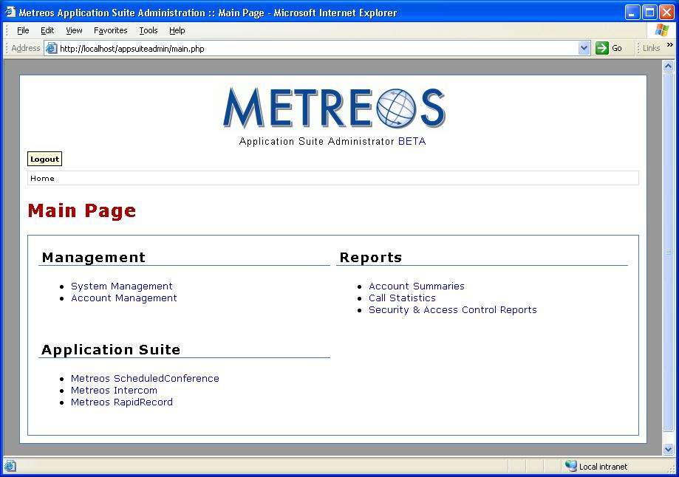
Figure 2: Main Configuration Page
From the main configuration page (Figure 2), you can navigate to all configuration and reporting options of the management console.

System Management – System management facilities include password maintenance and server name specification.

- Account Management – Account management facilities permit the establishment and maintenance of application user accounts.
- Account Summary Reports – Account summary reports display call statistics categorized by user, and can be optionally filtered.
- Call Statistics Reports – Call statistics reports show call details filtered by various criteria such as application.
- Security and Access Control Reports – Security reports detail security and access violations categorized by device.

System Management
Selecting System Management from the main configuration page displays the System Management page, as shown in Figure 3:

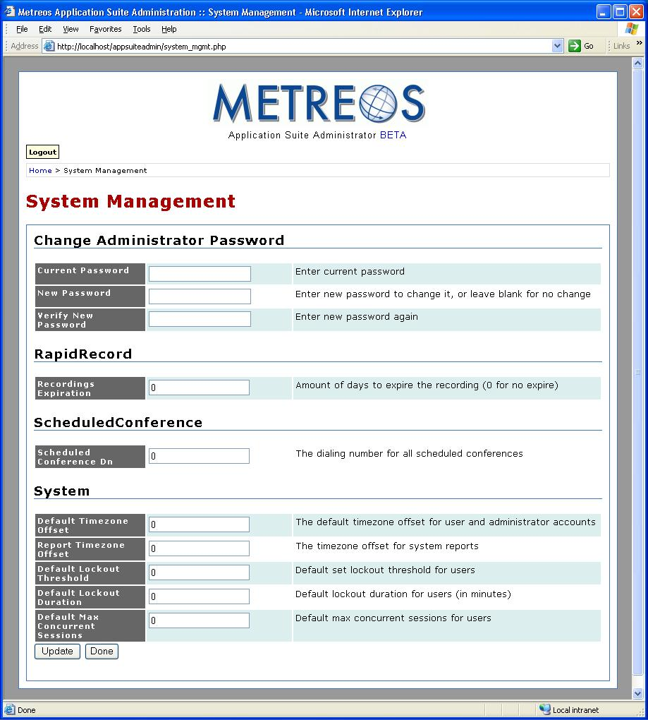
Figure 3: System Management
The following features are available on the System Management page:

- Change administrator password
- Metreos RapidRecord configuration
- Metreos ScheduledConference configuration
- System configuration

Change Administrator Password
To change the administrator password, enter both your current password and your new password in their respective text fields. Re-enter the new password in the indicated text field for verification.

RapidRecord
In the text field labeled Recordings Expiration enter the number days that a voice recording should be kept on disk.
Note: An entry of zero indicates that recordings do not automatically expire, and must be manually deleted.

ScheduledConference
In the text field labeled Scheduled Conference DN enter the number that a user will dial to schedule a conference using the Metreos ScheduledConfererence application.

System
- Default Time Zone Offset – Enter the difference between the local time and GMT, positive, negative, or zero, to be used for any account that does not specify a time difference.
- Report Time Zone Offset – Enter the offset from GMT, positive, negative, or zero, to be used for the calculation of time stamps in system reports.
- Default Lockout Threshold – Enter the number of consecutive failed logins before an account is locked from further login attempts. This threshold does not apply to individual accounts for which the lockout has been overridden.
- Default Lockout Duration – Enter the length of time that an account remains locked out. This duration does not apply to individual accounts for which the lockout has been overridden.
- Default Max Concurrent Sessions – Enter the maximum number of sessions a user account may have concurrently active. This parameter does not apply to individual accounts for which the lockout has been overridden.

Account Management

Selecting Account Management from the main configuration page displays the Account Management page, as shown in Figure 4:
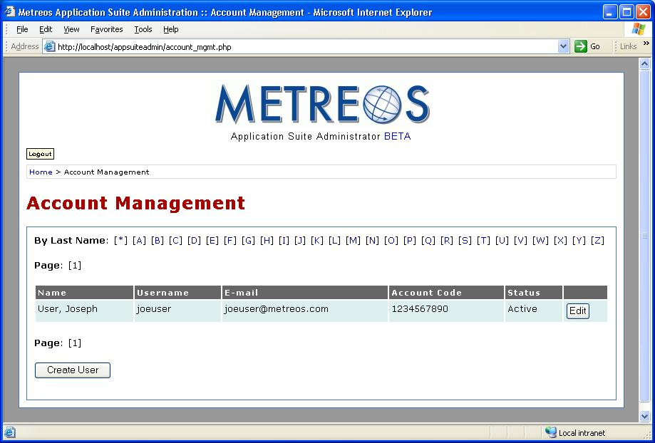
Figure 4: Account Management
Features available on the Account Management page are
- Create User Account
- Edit User Account

Create User Account
To create a new Metreos Application Suite user account, click the Create User button. Doing so displays an empty Edit User Account screen, the operation of which is described in the next section Edit User Account.

Edit User Account
To make changes to an existing Metreos Application Suite user account, click the button labeled Edit found at the end of the screen line containing the name of the user you wish to change. A populated Edit User Account screen is displayed, the operation of which is described in the next section Create User Account.

Create User Account

Selecting the Create User button from the Account Management page displays the Create User Account page, as shown in Figure 5:

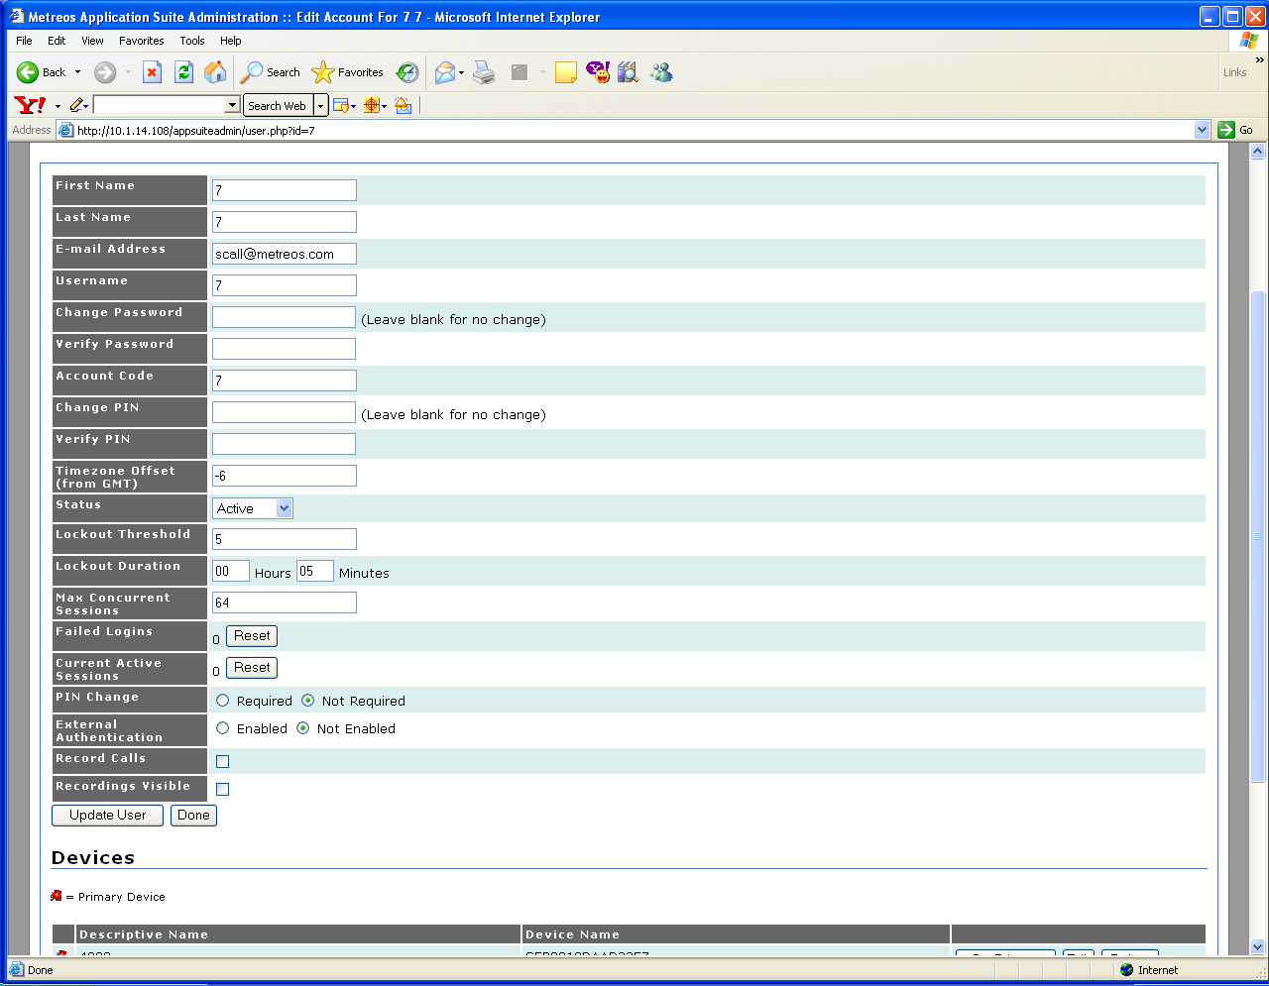
Figure 5: Create User Account

Entering Account Information
Complete the fields as described in the following sections for the new account.

Account Properties
- First Name; Last Name – The names by which this user of the Metreos Application Suite wants to be known.
- Email Address – The e-mail address at which this wishes to receive Application Suite notifications.
- Password; Verify Password – The password with which this user will be authenticated by each application. Re-enter the password in the Verify Password text field. If you are changing an existing account, and the password is not changing, leave these entries blank.
- Account Code – The account number with which this user of the Metreos Application Suite will be identified and authenticated.
- PIN; Verify PIN - The Personal Identification Number with which this user of the Metreos Application Suite will be identified and authenticated.
- Status – The account status. Use the supplied dropdown. Accounts may be inactivated and reactivated using the Status field.
- Time Zone Offset (from GMT) – The difference in hours by which this user’s local time differs from GMT. This entry can be positive or negative.
- Lockout Threshold – The number of times this user may have the login rejected, before the account is forced into a locked out state preventing further login attempts.
- Lockout Duration – The number of hours and minutes the account will remain locked out. If no entry is supplied for Lockout Duration, the Metreos Application Suite will not automatically unlock a locked account. In such a case you must manually unlock the account.
- Failed Logins; Concurrent Logins – Set by the Metreos Application Suite. The values indicate the number of times this account has experienced failed login attempts, and the number of times the account has attempted to log in while already logged in, respectively. You can reset either of these entries to zero using the button labeled Reset, found to the right of each entry.
- PIN Change – Checking the Required radio button requires the user to change the account PIN at the next login. Checking the Not Required radio button eliminates the requirement of changing the account PIN at the next login.
- External Authentication – Checking the Enabled radio button indicates that authentication of this user will be deferred to the configured LDAP directory. Checking the Disabled radio button eliminates this requirement.
- Record Calls – All calls initiated by this account are to be recorded.
- Recordings Visible – User’s phone display will show that the call is begin recorded. A button is also displayed that allows the user to be stopped and restarted.
Note: The Metreos RapidRecord application must be configured for this user in order to record calls. Refer to Error: Reference source not found on page Error: Reference source not found of this document for more information.

Edit User Account
Selecting the Edit button from an account record on the Account Management page displays the Edit User Account page. This page is similar to the new account page as shown in Figure 5, with the addition of Devices and External Numbers.

Entering Account Information
Enter any changes to the account record as described in the previous section Account Properties. Enter any devices, such as IP phones, to be associated with the account, and enter the numbers at which the account can be reached.

Devices
The Devices section lists the telephones at which this user can be reached.

For each telephone device, enter a friendly name for the device, such as office or home, and the MAC address (network interface card address) for each device. The MAC address of the phone can be obtained on the telephone menu display.

Press the button labeled Set Primary, located at the end of line containing the device information to set a device as the user’s primary telephone.

As you add devices, you will have the opportunity to add line numbers to be associated with the device.

External Numbers
The External Numbers section contains the telephone numbers for the current user. For each device, enter a friendly name for the device, such as pager or mobile and the number for each device.

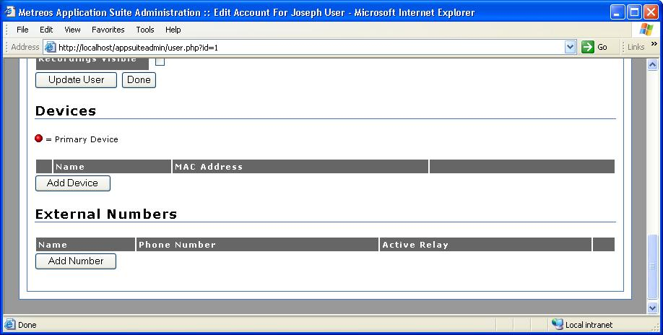
Figure 6: Edit User Account

Application Suite Reports

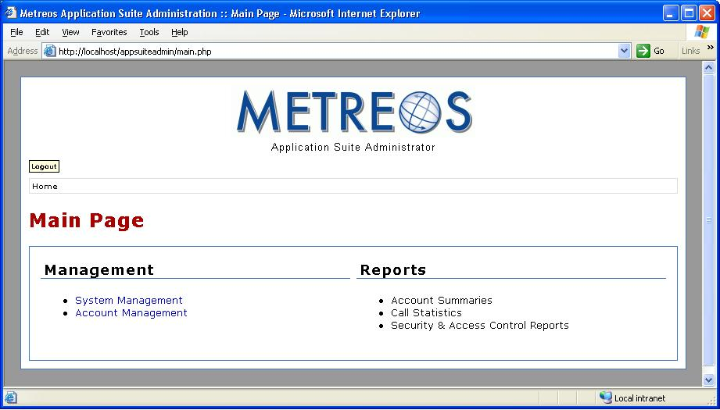
Figure 7: Main Configuration Page
The Metreos Application Suite reporting facility permits the accumulation and presentation of statistics and metrics pertaining to the account usage of each application in the suite. Reported statistics are commonly used for billing calls, detecting intrusion, and maintaining a record of customer contacts. All such administration reports may be accessed from the main administration page. The available reports are

- Account Summaries – Presents calls by account code, filtered by selected criteria.
- Call Statistics – Presents calls placed to selected clients, and associated with selected projects.
- Security and Access Control – Presents statistics on each device accessing each account.

Account Summary Reports
The Account Summary reports present statistics for each account code, such as cumulative call duration, average call length. The filtering criteria found at the top of the report page lets you show only accounts exceeding a specified threshold for any of the available metrics, or to quickly access statistics for any selected account code.

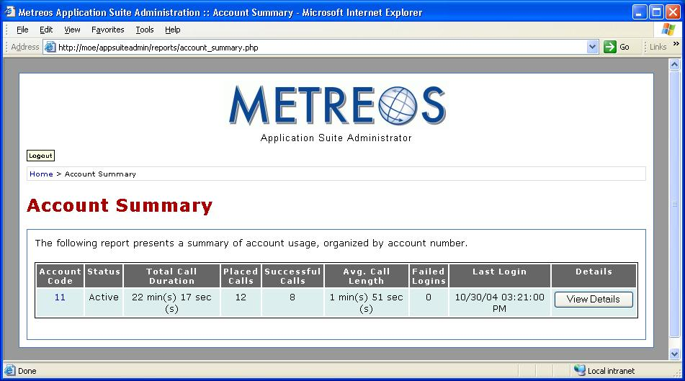
Figure 8: Account Summary Page

Call Statistics Reports
The Call Statistics reports show statistics reflecting calls placed from selected accounts, to particular clients, and associated with selected projects. The filtering criteria found at the top of the report page lets you show only accounts that communicated with a particular client, or that made calls billable to a selected project.

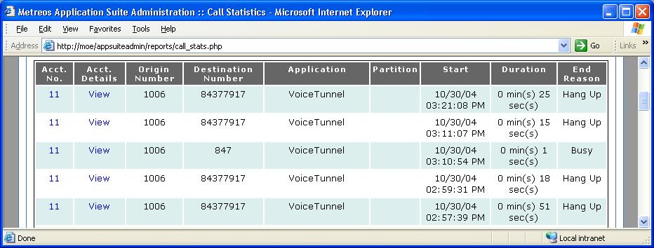
Figure 9: Call Statistics Report Page

Security and Access Control Reports
The Security and Access Control reports display detailed information on which devices are using which account codes. If an account is locked out or an unexpected concurrent sessions exceeded error occurs, this page can be used to determine the device committing the offending login attempt.

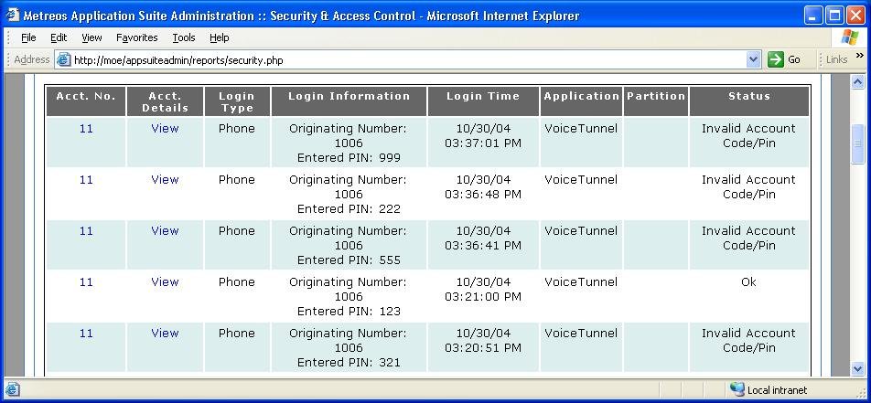
Figure 10: Security And Access Control Reports

Application Configuration
Individual applications in the Metreos Application Suite require installation and configuration. Cisco CallManager may also require application-specific configuration. Refer to the Metreos Communications Environment Integration Guide for information on application specific settings in CallManager.

Setting the Trigger Value for Metreos Applications
Each application in the Metreos Application Suite has a triggering parameter. The triggering parameter is set in the MCE using the Metreos Management Console. You can find detailed information about the Metreos Management Console in the Metreos Communications Environment Management Console Guide. The following procedure describes how to set the trigger value for applications in the Metreos Application Suite:

- Launch the Metreos Management Console and login:

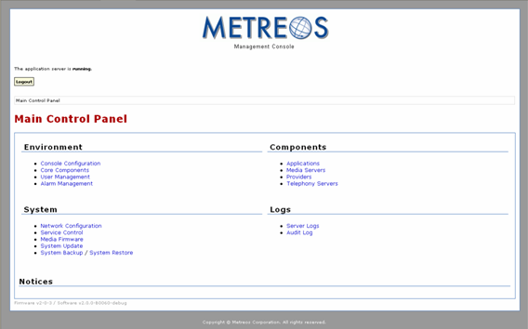
Figure 11: Metreos Management Console
- Click Applications to display the Applications page:

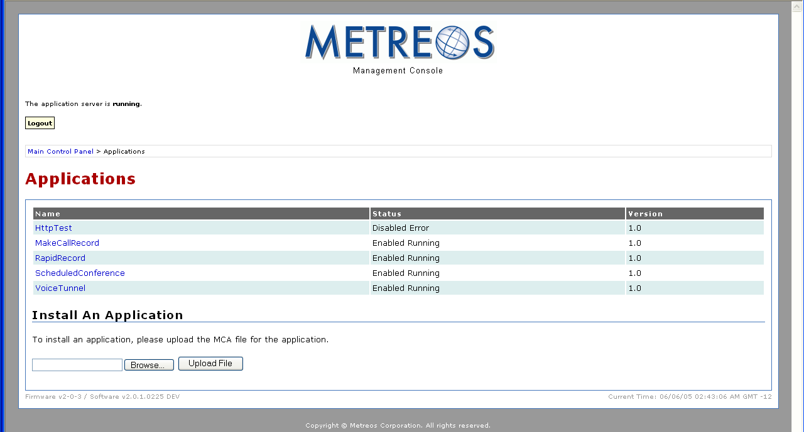
Figure 12: Applications Page
- Select the application for which you want to set the trigger parameter:

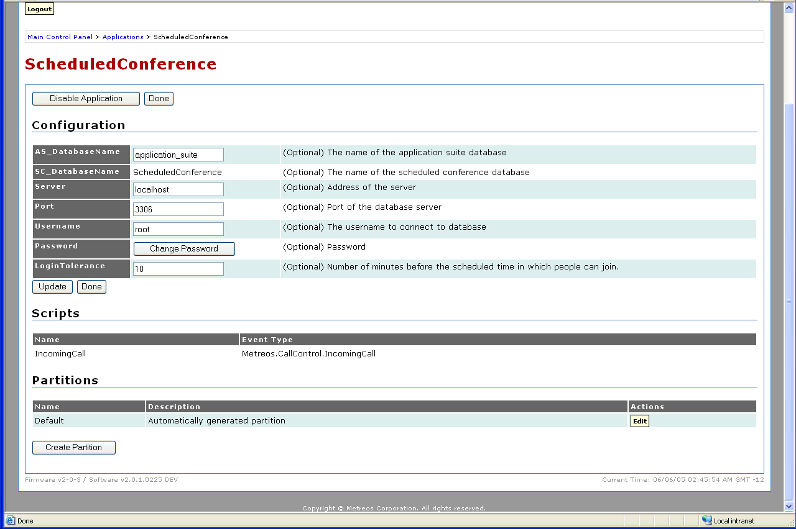
Figure 13: Application Configuration Page for Metreos ScheduleConference
- Click the Edit button at the bottom of the page in the Partitions section:
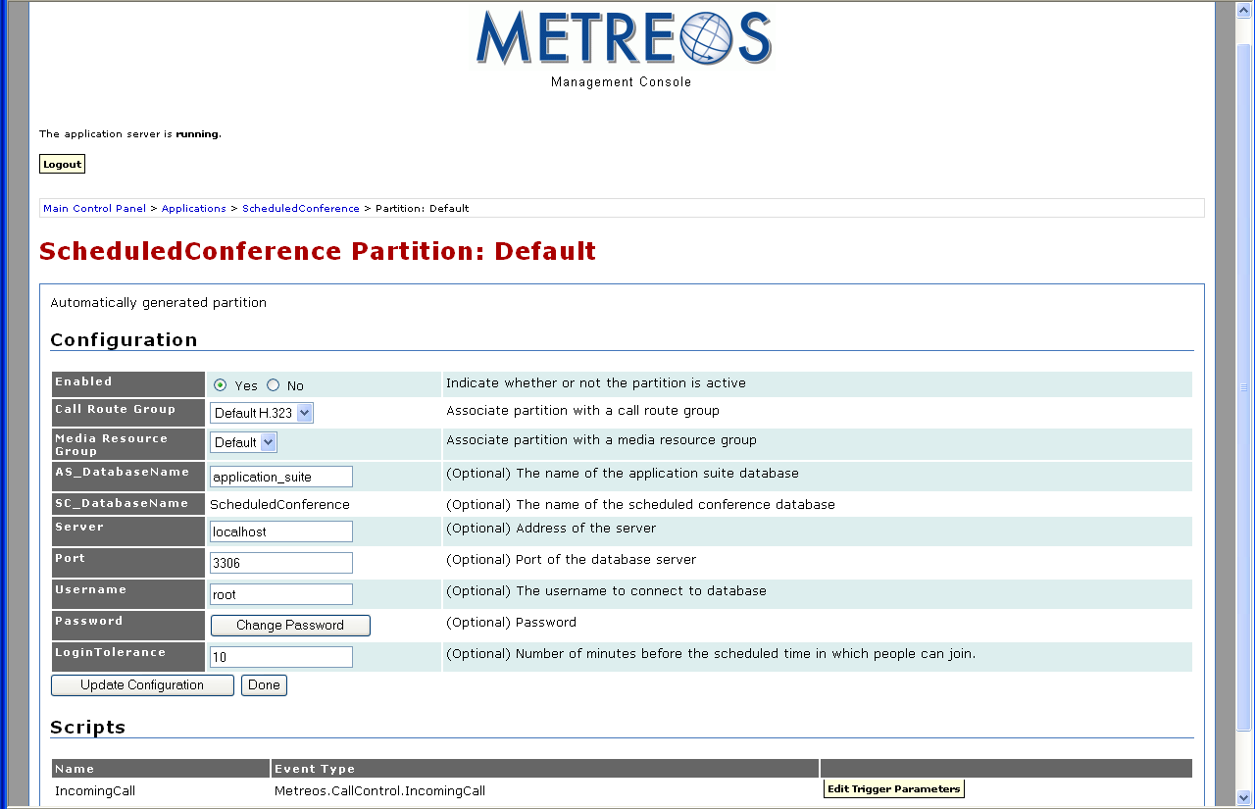
Figure 14: Default Application Partition Page for Metreos ScheduleConference
- Click the Edit Trigger Parameters button at the bottom of the page in the Scripts section.

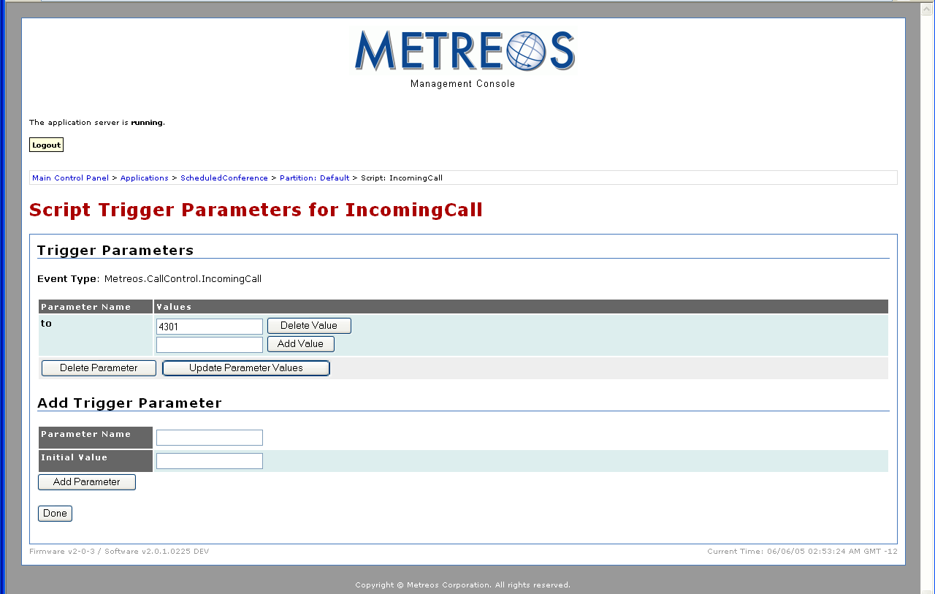
Figure 15: Trigger Parameter Page for Metreos ScheduleConference

In the case of our example application, ScheduledConference, the trigger is an event: Metreos.CallControl.IncomingCall with a value of an extension to be dialed by the user. Cisco CallManager must be configured such that when a user dials this extension, the call is routed to the Application Runtime Environment. Refer to the Metreos Communications Environment Cisco CallManager Integration Guide for details.

Not all applications use an incoming call event for the trigger parameter and some applications require multiple triggering events. The following table specifies the type of triggers each Metreos application requires:

Application | Event | Value
Metreos VoiceTunnel | Metreos.CallControl.IncomingCall | Set by administrator
Metreos ClickToTalk | Metreos.CallControl.IncomingCall | Set by administrator
 | Metreos.Providers.HTTP.GotRequest | /click-to-talk/initiateCall
 | Metreos.Providers.HTTP.GotRequest | /click-to-talk/image.xml
 | Metreos.Providers.HTTP.GotRequest | /click-to-talk/errors.xml
 | Metreos.Providers.HTTP.GotRequest | /click-to-talk/stopRecord
 | Metreos.Providers.HTTP.GotRequest | /click-to-talk/validate
Metreos ActiveRelay | Metreos.CallControl.IncomingCall | Set by administrator (per user)
 | Metreos.Providers.HTTP.GotRequest | /ActiveRelay
Metreos ScheduledConference | Metreos.CallControl.IncomingCall | Set by administrator
Metreos Intercom | Metreos.Providers.HTTP.GotRequest | /LaunchIntercom
 | Metreos.Providers.HTTP.GotRequest | /ShowIntercomGroups
 | Metreos.Providers.HTTP.GotRequest | /IntercomAddWorker
Metreos RapidRecord | Metreos.CallControl.IncomingCall | Set by administrator
 | Metreos.Providers.HTTP.GotRequest | InternalSendEvent
Table 1: Application Triggering Events

Metreos ActiveRelay Configuration
Metreos ActiveRelay™ allows your business contacts to call you using a single number, regardless of your physical location. Metreos ActiveRelay bridges your cellular telephone to your office telephone and rings both simultaneously, allowing you to answer either phone.

Once connected, you can easily transfer the call to other devices that are configured with ActiveRelay. To the caller, the call sounds like a normal call, and does not exhibit multiple ring sequences common to older style call forwarding applications.

Configuring the Metreos ActiveRelay Cisco IP Phone Service
Before Metreos ActiveRelay can be used, the phone service must be installed on CallManager, and the participating phones subscribed to the service. To do so, follow the instructions in the Metreos Communications Environment Cisco CallManager Integration Guide.

Configuring Metreos ActiveRelay
Use the following procedure to configure Metreos ActiveRelay:

- Launch the Metreos Management Console and login:

Figure 16: Metreos management Console
- Click the Applications link

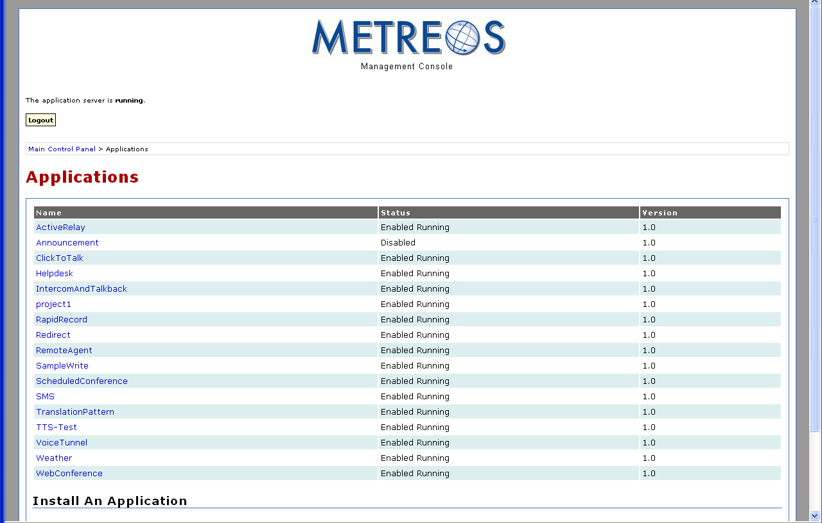
Figure 17: Metreos Management Console Applications Page
- Click the ActiveRelay link:

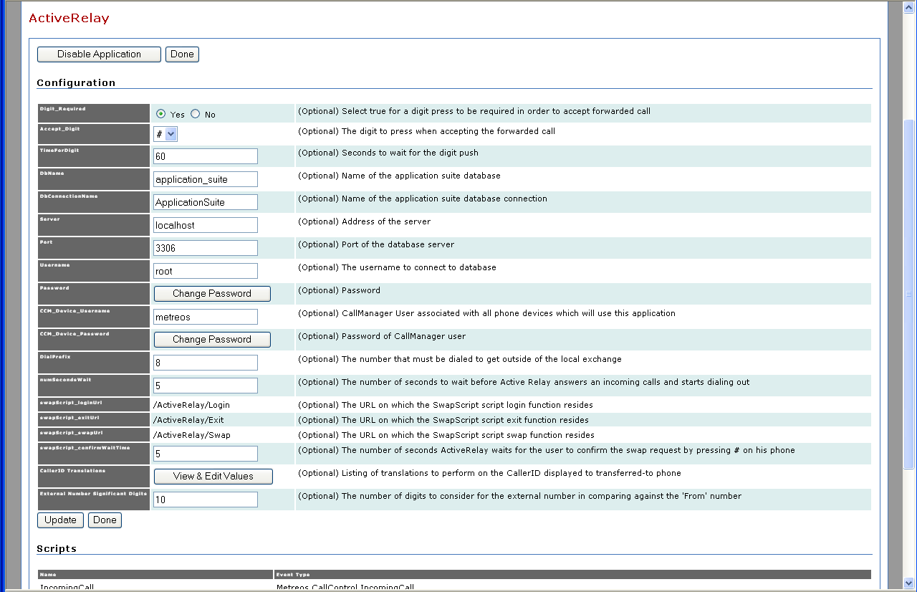
Figure 18: Metreos ActiveRelay Configuration Page
- Fill out the form.
- Click Update.

Metreos ClickToTalk Configuration
Metreos ClickToTalk™ is a speed dialing application permitting the calling of any party in a contact list with a single click. Metreos ClickToTalk can be used by anyone in a Cisco CallManager group using a Cisco 7940, 7960, or 7970 IP telephone. A ClickToTalk user might select an entry from his or her Microsoft Outlook contact list, click a button on the Outlook tool bar, and ClickToTalk will dial that contact from that user’s IP phone. Conferencing and recording of calls are also supported.

Use the following procedure to configure Metreos ClickToTalk:

- Launch the Metreos Management Console and login:

Figure 19: Metreos management Console
- Click the Applications link

Figure 20: Metreos Management Console Applications Page
- Click the ClickToTalk link:

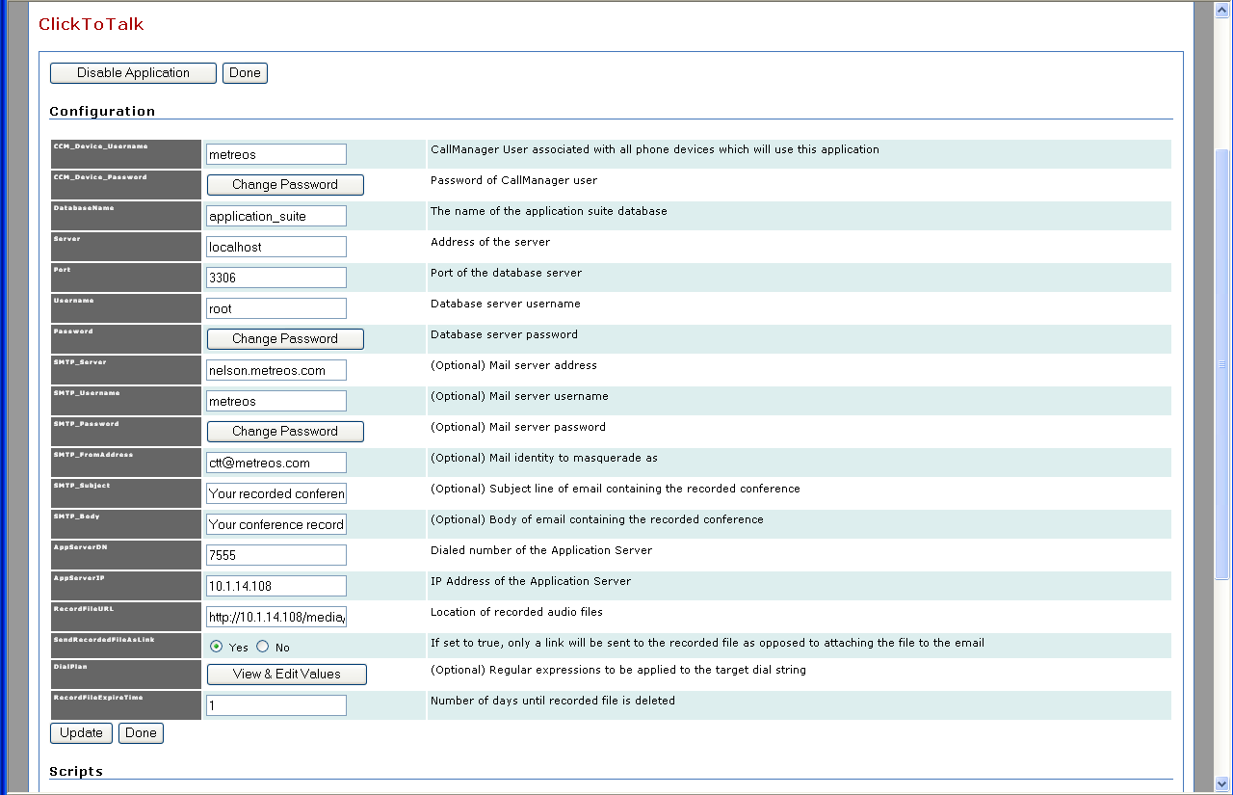
Figure 21: Metreos ClickToTalk Configuration Page
- Fill out the form.
- Click Update.

Metreos Intercom Configuration
Metreos Intercom™ permits instant communication over IP phones without the need to dial a number. After lifting the handset, you select users from a menu, and audio connectivity is instantly established.

Metreos Intercom can be configured to act as a group paging system for the broadcast of voice messages or pages, similar to a traditional paging system. Configuring Metreos Intercom is a three step process:

- Install the IP phone service
- Create intercom groups
- Configure Intercom

Installing the Metreos Intercom Cisco IP Phone Service
Before Metreos Intercom can be used, the phone service must be installed on CallManager, and the participating phones subscribed to the service. To do so, follow the instructions in the Metreos Communications Environment Cisco CallManager Integration Guide.

Creating Intercom Groups
Metreos Intercom uses the concept of an intercom group. To broadcast a Metreos Intercom message, select an intercom group on the IP phone display. You can then speak normally without lifting the handset, and the voice message is broadcast to the phone speaker of each member of the group. Intercom groups can only be created by the administrator. If the administrator has defined the group to be public, anyone can join or leave the group once it has been created. If the group is private, its membership is determined solely by the administrator.

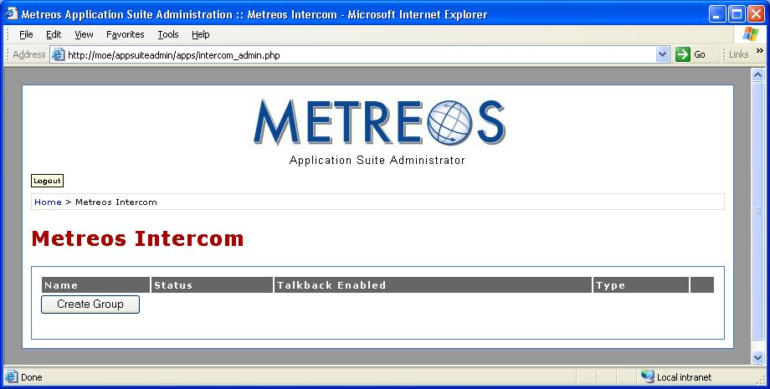
Figure 22: Intercom Groups Page

Creating an Intercom Group
In order for users to broadcast or hear voice messages over Metreos Intercom, each user must be a member of the intercom group selected for broadcast

To create an intercom group

- Select Metreos Intercom from the main administration page. You will be presented with the Metreos Intercom page, as shown in Figure 22on page37. From there click the button labeled Create Group. The Create Intercom Group page is displayed, as shown in Figure 23:

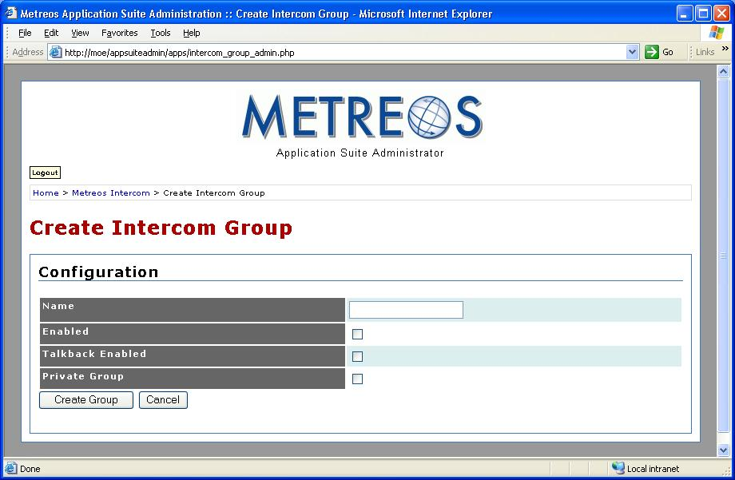
Figure 23: Create Intercom Group
- Fill out the form:

- Name – The group name
- Enabled – Enables the intercom group
- Talkback Enabled – Allows non-initiating members of the group to be able to talk back over the intercom channel
- Private Group – Check to designate the intercom group private (only the administrator can add and remove users). Leave unchecked to designate the intercom group as public (any user can join or leave the group at will).

- Click Create Group.

Configuring Intercom
Configure Metreos Intercom using the following procedure:

- Launch the Metreos Management Console and login:

Figure 24: Metreos management Console
- Click the Applications link:

Figure 25: Metreos Management Console Applications Page
- Click the IntercomAndTalk link:

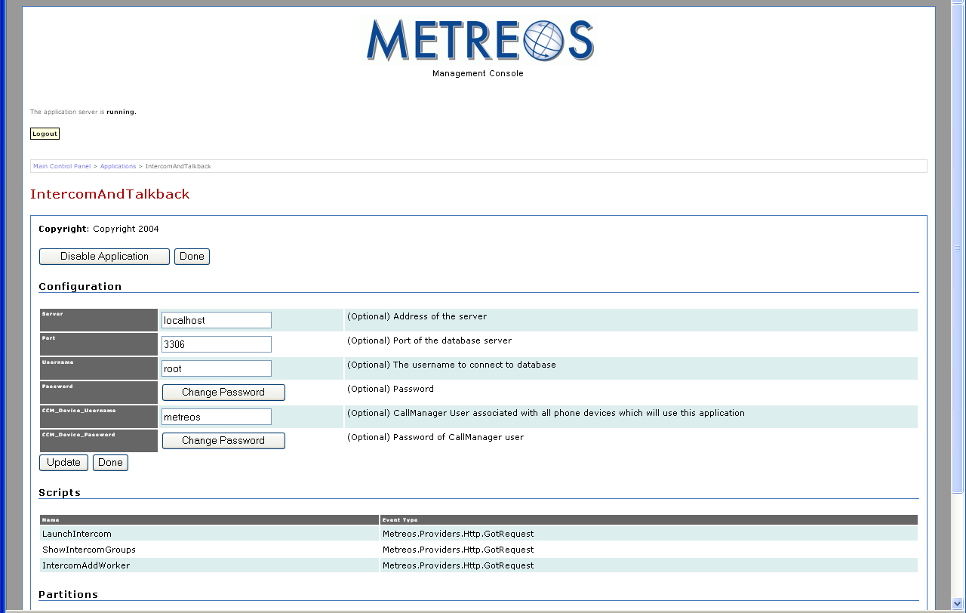
Figure 26: Metreos InterCom Configuration Page
- Fill out the form.
- Click Update.

Metreos RapidRecord Configuration
Metreos RapidRecord™ automatically records calls placed to and from a configured group of frontline devices, permitting seamless, hands-off call recording. Recorded calls can be played back either from a Web interface, or directly from the IP phone that placed or received the call.

Configuring Metreos RapidRecord
Metreos RapidRapid is configured using the Metreos Management Console. Use the following procedure:

- Launch the Metreos Management Console and login:

Figure 27: Metreos management Console
- Click the Applications link

Figure 28: Metreos Management Console Applications Page
- Click the RapidRecord link:

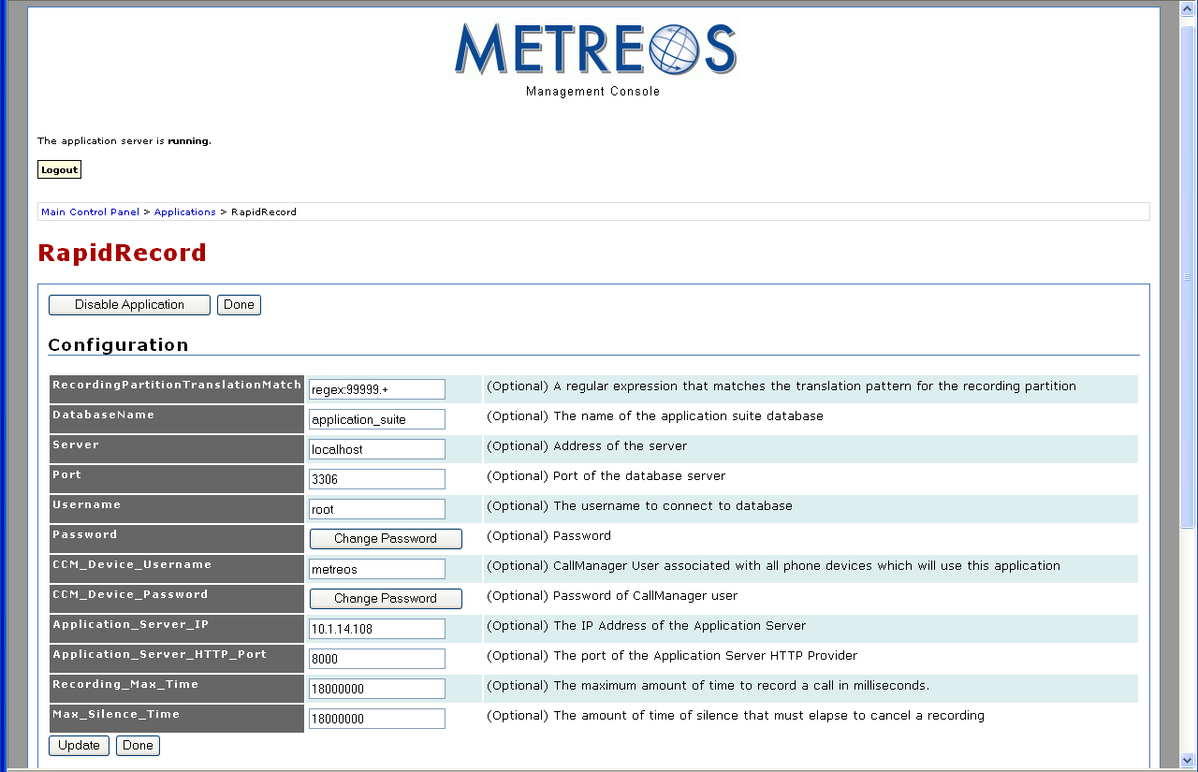
Figure 29: RapidRecord Configuration Page
- Fill out the form.
- Click Update.

Metreos ScheduledConference Configuration
Metreos ScheduledConference™ is a Web-scheduled dial-in and dial-out conferencing system. Conferences can be scheduled from an easy-to-use Web interface, eliminating the need for costly operator or administrative assistance when setting up conference calls. Features include adding conference parties, party mute and unmute, and participant removal.

Metreos ScheduledConference is configured using the Metreos Management Console. Use the following procedure:

- Launch the Metreos Management Console and login:

Figure 30: Metreos management Console
- Click the Applications link

Figure 31: Metreos Management Console Applications Page
- Click the ScheduledConference link:

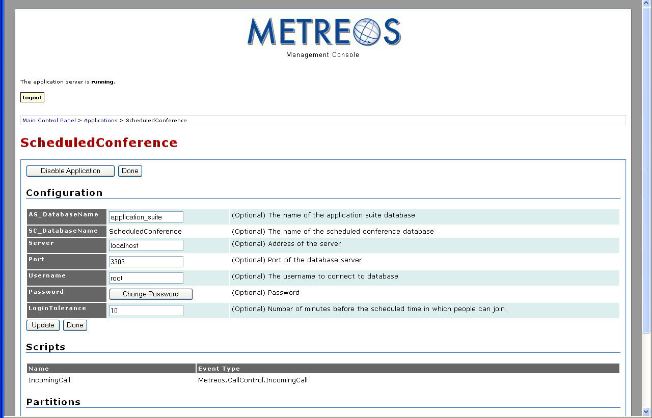
Figure 32: Metreos ScheduledConference Configuration Page
- Fill out the form.
- Click Update.

Metreos VoiceTunnel Configuration
Metreos VoiceTunnel™ allows a remote user to connect to any enterprise IP communications system and place calls as if they were local to the system. With Metreos VoiceTunnel, the enterprise can

- Place all calls locally, avoiding international and long-distance toll charges
- Authenticate call usage and apply a broad range of policies to the billing and accounting of communications costs
- Manage, monitor, and report on usage of the communications system

Use the following procedure to configure Metreos VoiceTunnel:

- Launch the Metreos Management Console and login:

Figure 33: Metreos management Console
- Click the Applications link:

Figure 34: Metreos Management Console Applications Page
- Click the VoiceTunnel link:

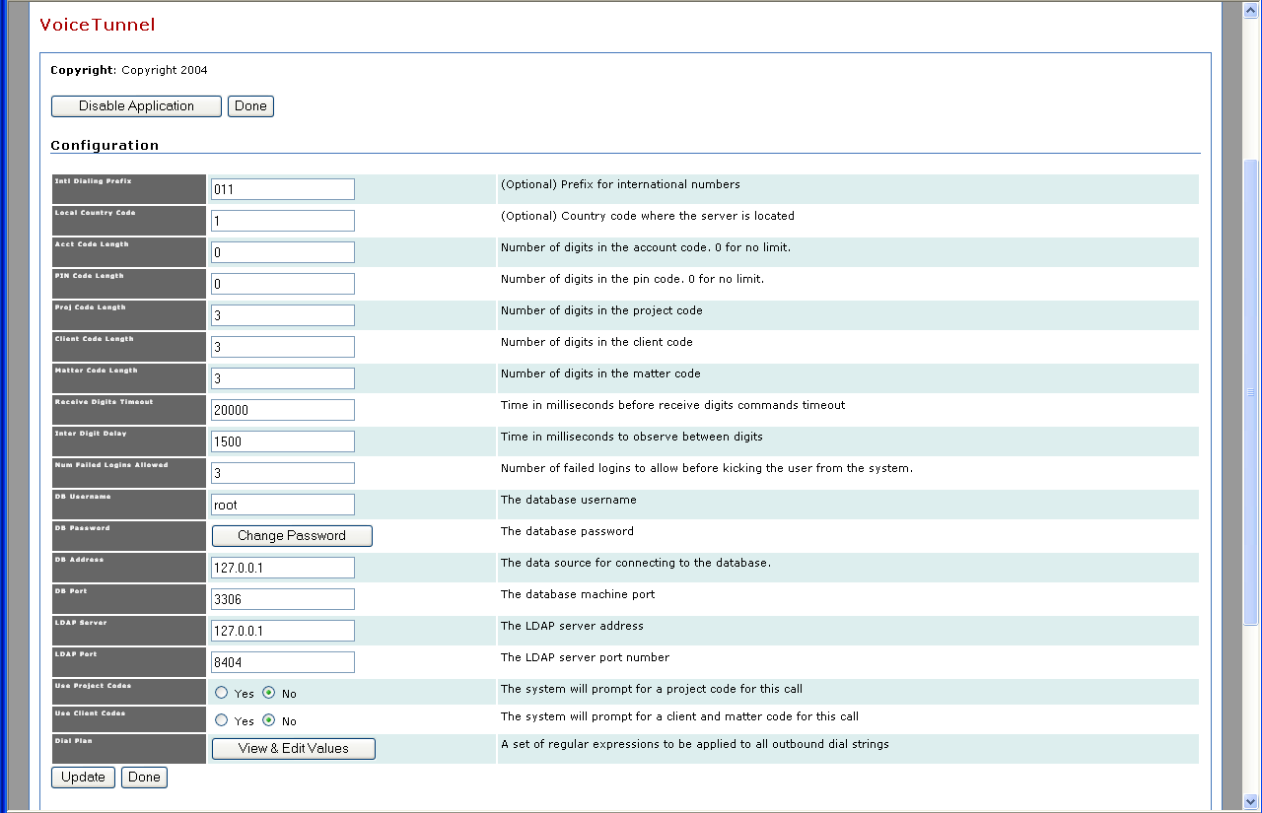
Figure 35: Metreos VoiceTunnel Configuration Page
- Fill out the form.
- Click Update.

Appendix A: Cisco CallManager Setup
Most of the Metreos Application Suite applications can use either the H.323 or JTAPI protocol to perform call control, but RapidRecord cannot be used with JTAPI.

ActiveRelay also cannot use JTAPI to watch for the incoming call that triggers the application, but it can use JTAPI to place its outbound calls. This Appendix outlines the Metreos Application Suite-specific CallManager configuration required by the H.323 and JTAPI protocols.

Common Procedures
Many of the setup procedures are unique for each protocol. Some procedures, however, are common to both. This section describes the configuration procedures common to H.323 and JTAPI.

Global Metreos User Setup
From the CallManager Administration Web page, go to User → Add a new user. Create a new user with a user ID of metreos, and a password of metreos. Check the Enable calling party number modification box. Every device to be used with the Application Suite must be associated with the metreos user account to run most applications in the Metreos Application Suite.

Partitions
The following three Partitions are required:

- RecordedDevices partition – Lines that will be used with RapidRecord must reside in the RecordedDevices partition.
- Unrestricted partition – Lines that will not be used with RapidRecord must be placed in the Unrestricted partition.
- ApplicationServer partition – Route patterns designed to intercept all calls must reside in the ApplicationServer partition. This technique serves to route all incoming calls to the MCE so that the MCE can in turn route them to the appropriate Metreos application as necessary.

Calling Search Spaces:
The following three Calling Search Spaces are required:

- Unrestricted CSS – The Calling Search Space used by unrestricted devices. Every phone device in the Unrestricted Partition has the Unrestricted Calling Search Space.
- RecordedDevices CSS – Every phone device in the RecordedDevices Partition has the RecordedDevices Calling Search Space.
- ApplicationServer CSS: The Application Server Calling Search Space. The ApplicationServer CSS is used by the Application Runtime Environment for the outbound calls that it must place.

Calling Search Space Setup:
Configure the three Calling Search Spaces listed in the previous section Calling Search Spaces to contain the bulleted Partitions.

- Unrestricted:
  - Unrestricted
  - RecordedDevices
- RecordedDevices
  - ApplicationServer
- ApplicationServer
  - RecordedDevices
  - Unrestricted

When a line that uses the Unrestricted CSS makes a call, CallManager will first search the Unrestricted Partition for a match. If it does not find a suitable match, the CallManager will search the RecordedDevices Partition.

When a line that uses the RecordedDevices CSS places a call, CallManager will search only the ApplicationServer Partition. That Partition should contain a route pattern to intercept all calls as described in Route Patterns for Recording section on page 55. CallManager will then force that call through the Application Runtime Environment.

The ApplicationServer CSS is used by Application Runtime Environment. When the Application Runtime Environment places a call, it will first look for the destination number in the RecordedDevices Partition.

Adding Cisco IP Phone Devices:
When configuring phone devices for your users, be aware of the following:

- Ensure the device is associated with the metreos user. If the user does not need ActiveRelay or RapidRecord, associate each line on the device with the Unrestricted CSS, and place it in the Unrestricted Partition.
- To use Metreos ActiveRelay
  - users must have two lines that reside in the Unrestricted Partition and use the Unrestricted CSS
  - the primary line must rollover to a secondary line
To meet this requirement set the Forward Busy field on the first line to the number of the secondary line.
- To use Metreos RapidRecord, each line that is to be recorded must be placed in the RecordedDevices Partition, and utilize the RecordedDevices CSS. Lines can rollover as necessary.
- After configuring the lines for the device, reset the device.
- A user can not be configured to use both Metreos RapidRecord and Metreos ActiveRelay at the same time.

Cisco IP Phone Services Setup:
Two applications utilize Cisco IP Phone Services:

- Metreos ActiveRelay
- Metreos Intercom

These two IP services are triggered when a request is sent to a specific URL in the Application Runtime Environment. The query parameters on which applications are triggered can be changed through the MCE Administrator console. Refer to Metreos ActiveRelay Configuration on page Error: Reference source not found and Metreos Intercom Configuration on page Error: Reference source not found for details. This section presents the procedure for configuring IP phone services using the default triggering criteria for Metreos ActiveRelay and Metreos Intercom. If you change the default triggering criteria you must supply matching data to Cisco CallManager.

The Application Server, by default, listens for HTTP requests on port 8000. Proceed to
Feature → Cisco IP Phone Services page in CallManager Administrator. For each of the following services, click Add a New IP Phone Service:

  - ActiveRelay IP service:
- Specify ActiveRelay for the Service Name field
- Specify http://MCE_IPAddress:8000/ActiveRelay?device=#DEVICENAME# for the Service URL field
- Click Insert
- Intercom IP service:
- Specify Intercom for the Service Name field
- Specify http://MCE_IPAddress:8000/ShowIntercomGroups?device=#DEVICENAME# for the Service URL field
- Click Insert.

Note: Each device that uses Metreos ActiveRelay must be subscribed to the ActiveRelay service and each device that uses Metreos Intercom must be subscribed to the Intercom service.

The #DEVICENAME# token is recognized by the Cisco IP phone, and then replaced with the Device Name of the phone, before the request is sent out to the Application Runtime Environment.

Creating CallManager Clusters
You must set up a CallManager cluster using the Metreos Management Console. Refer to the Creating CTI Telephony Devices section of the Metreos Communications Environment Management Console User Guide for details.

H.323 configuration
The Application Server is set up as both a gateway and a H.323 device in CallManager. The Application Runtime Environment must have two IP addresses associated with its network adapter; one for the gateway configuration, and one for the H.323 phone devices. Refer to the Metreos Communications Environment Management Console User Guide for more information on network settings configuration.

H.323 Gateway Setup:
Create a H.323 Gateway:

- In CallManager Administrator, click on Device → Gateway. Select Add a New Gateway.
- Select H.323 Gateway for the Gateway type field
- Click the Next button.
- Set the Device Name field to the first IP address of the Application Server network adapter you configured earlier.
- Set the Device Pool to Default.
- Set the Calling Search Space field to ApplicationServer.
- Click the Insert button.
- Configure a MCE H.323 gateway using the Metreos Management Console. Refer to the Creating H.323 Call Route Groups and Gateways section of the Metreos Communications Environment Management Console User Guide for details.

H.323 Device Setup:
Create a H.323 phone device:

- In CallManager Administrator, click on Device → Phone.
- Select Add a New Phone.
- Select H.323 Client for the Phone type field
- Click the Next button.
- Set the Device Name to the second IP address of the appliance.
- Set the Device Pool to Default.
- Click the Insert button.

The H.323 Phone Device is required by two applications: Metreos RapidRecord and Metreos ActiveRelay.

Metreos RapidRecord requires you to add a new line on the H.323 device for each line in the RecordedDevices Partition a corresponding line must be added to the H.323 device. Configure each line that you add to the H.323 device according to the following guidelines.

- Configure the line to be in the Unrestricted Partition, and to have the Unrestricted CSS.
- Set the Forward All → Destination field to the same number as the Directory Number field for this line.
- For every recorded line that you configure for H.323 devices, the
Forward All → Calling Search Space field should be set to RecordedDevices.

Metreos ActiveRelay requires you to add a new line on the H.323 phone device for every user wanting to use the Metreos ActiveRelay application. This line number should be the same as the appsuiteadmin-configured primary line of the primary device for the user in question. Use the following procedure:

- Configure each line to be in the Unrestricted Partition.
- Configure each line to have an Unrestricted CSS.
- Set the Forward Busy field to the directory number of the second line for the device in question.
- Reset the device.
- Add the line number to the values of the to trigger parameter in the ActiveRelay Default partition. Refer to Setting the Trigger Value for Metreos Applications on page 28 for details.

Note: The use of the Metreos ActiveRelay and Metreos RapidRecord applications on the same line is not supported.

Route Patterns for Recording
The route patterns described in this section must route to the Application Runtime Environment gateway you previously created. Depending on your local configuration, you might be required to add two or more route patterns to the Application Server partition.

The Application Runtime Environment has its own unique Calling Search Space, so that all calls placed by the runtime will be routed by its CSS. All calls made from a recorded device, for example, will have the same CSS as the Application Runtime Environment. These calls have the same CSS as the Application Runtime Environment, because the RapidRecord application intercepts them and connects them to the intended party. If, for example, you do not want to allow any user who has a recorded device to make local calls, do not create the first pattern in the following route pattern list (@):

- @ – Intercepts all call patterns for a given Numbering Plan, such as the North American Numbering plan. Depending on your phone system you might want to change this pattern to 9.@ to match your local and long distance prefix digit calling pattern. The Prefix Digits (Outgoing Calls) field in the Called Party Transformations section should contain the value 99999, a requirement of Metreos RapidRecord. The pattern should reside in the ApplicationServer partition.
- 1XXX – Intercepts all calls containing four digits, for which the first digit is 1. This pattern is required for internal calls. Some phone systems support internal calling with multiple dialing patterns. A system might, for example, require four digits for some numbers or devices and five digits for others.

In such cases a route pattern of this form must be created for each dialing requirement. In our example of a four digit and five digit dialing system a 1XXX route pattern and a 1XXXX route pattern must be created.

You should create a route pattern of this form for all numbers that the recorded user might dial. If, for example, the user has a need to dial 4 digit numbers beginning with 1 and five digit numbers beginning with 2, you must create route patterns that intercept those dialing patterns.

The Prefix Digits (Outgoing Calls) field in the Called Party Transformations section should contain the value 99999, a requirement of Metreos RapidRecord. These patterns should reside in the ApplicationServer partition, and they should point to the previously created gateway.

You must also set the to field of the trigger parameter in the RapidRecord Default partition to regex: 99999.+. Refer to Setting the Trigger Value for Metreos Applications on page 28 for details.

Other Route Patterns
Users access Metreos VoiceTunnel, Metreos ClickToTalk, and Metreos ScheduledConference accessed through unique directory numbers. Use the following procedure to create a route pattern for these applications:

- Create a route pattern containing no wildcard digits, such as 7000, and point it to the IP address of the Application Runtime Environment gateway. These route patterns should reside in the Unrestricted partition.
- Enter the route pattern in the to field of the trigger parameter of the Default partition for each application except Metreos ActiveRelay. Refer to Setting the Trigger Value for Metreos Applications on page 28 for details.
- Create duplicates of the VoiceTunnel and ScheduledConference patterns, but not ClickToTalk. Use the previously described procedure—but place these duplicates in the ApplicationServer partition, and set the Prefix Digits (Outgoing Calls) field in the Called Party Transformations section to the value 99999. Doing so allows devices in the RecordedDevices Partition to access these applications.

Note: Metreos ActiveRelay and Intercom do not require route patterns.

JTAPI configuration
You must create several CTI Route Points, some of which require multiple lines. The MCE uses these CTI Route Points for two purposes:

- To monitor and control calls coming into a Route Point’s lines
- To place outbound calls

Refer to the Creating CTI Telephony Devices section of the Metreos Communications Environment Management Console User Guide for information on how to configure the MCE to use a CTI Route Point.

Note: Metreos RapidRecord does not support JTAPI. Also, Metreos ActiveRelay cannot use JTAPI to watch for the incoming call that triggers an application, but it can use JTAPI to place outbound calls.

CTI Route Point Setup
Use the following procedure to set up a CTI route point:

- From the CallManager Administrator page, navigate to Device → CTI Route Point.
- Click the Add a New CTI Route Point link.
- Set the Device Name field to MCE_RT_PT_GEN, or to another name of your choice. You must use this name later when configuring CTI Device Pools in the Application Runtime Environment.
- Set the Device Pool field to Default.
- Click the Insert button to add the route point to CallManager. If CallManager prompts you as to whether you want to add a line to this route point, select either No or Cancel.

The MCE_RT_PT_GEN route point can be used by Metreos VoiceTunnel, Metreos ScheduledConference, and Metreos ClickToTalk applications. If you plan to use JTAPI with Metreos ActiveRelay to place outbound calls, another Route Point is required. The route point you create will be used exclusively by ActiveRelay. To add this ActiveRelay-specific route point, follow the procedure presented in the first paragraph of this section—but set the Device Name field to MCE_RT_PT_AR.

Associate the CTI Route Points with the metreos User:
The newly-created route points must be associated with the metreos user. Details about the metreos user are provided in the Global Metreos User Setup section of this Appendix. Use the following procedure associate CTI route points with the user:

- From the CallManager Administrator page, browse to User → Global Directory, and then locate and select the metreos user.
- Follow the Device Association link from the User Configuration page.
- Locate the route point devices that you created earlier.
- Check the checkbox next to each of the devices.
- Click the Update Selected button.

Adding lines to the CTI Route Points
Users access Metreos VoiceTunnel, Metreos ClickToTalk, and Metreos ScheduledConference through unique directory numbers. You must add a line to the MCE_RT_PT_GEN route point for each of these applications. Use the following procedure:

- Add a new line to the MCE_RT_PT_GEN route point.
- Set the Directory Number field to app_directory_number.
- Enter app_directory_number in the to field of the trigger parameter of the Default partitions for each application. Refer to Setting the Trigger Value for Metreos Applications on page 28 for details.
- Set the Partition field to Unrestricted.
- Set the Calling Search Space field to ApplicationServer.
- Click the Add button.

If you created the MCE_RT_PT_AR route point for Metreos ActiveRelay, you must add one new line. The directory number you assign to this line will be the CallerId number that is displayed on all outbound calls placed by ActiveRelay. Use the following procedure.

- Add a new line to the MCE_RT_PT_AR route point.
- Set the Directory Number field to your_directory_number
- Set the Partition field to Unrestricted.
- Set the Calling Search Space field to ApplicationServer.
- Click the Add button

Filtering Criteria and Download options may not be available in the initial release.
Filtering Criteria and Download options may not be available in the initial release.

